

**Professional Elective – Artificial Intelligence**

**RESUME SCREENING**

Samanvi Arcot Chinthinreddy Sindhu Gankidi Nikitha

Computer Science Department Electronics and communication department Electronics and communication department SR University SR University SR University

Mohanarupa Guggila

Electronics and communication department SR University

This work was supported by SR University

**ABSTRACT**

Recruitment is a tedious process wherein the first task for any recruiter is to screen the resumes. Resume screening is the process of determining whether a candidate is qualified for a role based his or her education, experience, and other information captured on their resume. It becomes quite tough for hiring teams to read resumes and select the best one based on the requirements. The number of resumes received is one of the biggest factors that increases time to fill. An average job opening receives 250 resumes and up to 88% of them are considered unqualified. This means a recruiter can spend up to 23 hours screening resumes for a single hire. So, we have developed a web application of resume screening where in we have to give job description of the profile and resumes we want to screen as input and it will give the percentage of the resume which will match to the job description. If the matched percentage is above 60% then the respected candidate will be shortlisted for job else rejected. By choosing good candidates, we can increase the company goals exponentially.

**INTRODUCTION**

Resume screening is the process of determining whether a candidate is qualified for a role based his or her education, experience, and other information captured on their resume. It becomes quite tough for hiring teams to read resumes and select the best one based on the requirements. The number of resumes received is one of the biggest factors that increases time to fill. An average job opening receives 250 resumes and up to 88% of them are considered unqualified. This means a recruiter can spend up to 23 hours screening resumes for a single hire. Recruitment is a 200-billion-dollar business. It deals with hiring the best fit candidates having the relevant skills for a given job profile from an immensely large pool of candidates. If a company has any job opening for a position, scores of candidates mail their resumes to the company to apply for that opening. In the hiring process, the first task for any recruiter is to screen the resumes of all the job applicants. Any company having a job opening for a particular position will have their mail inboxes bombarded with thousands of emails from the aspiring job applicants every single day. Selecting the prospective candidates for that job position from a large pool of candidates for any recruiter is very tedious. It is an extremely daunting task for the recruiters of a company to manually go through thousands of resumes and select the most appropriate candidates for the job. Out of those thousands of resumes submitted to the company for the given job posting, about 75% of them do not showcase the relevant skills that are required for the job profile.

**LITERATURE REVIEW**

This paper focuses majorly on the design of the web application which will be used to screen resumes for a particular job posting. In the proposed system, a web application will encourage the job applicant candidates as well as the recruiters to use it for job applications and screening of resumes. Recruitment is a tedious process wherein the first task for any recruiter is to screen the resumes. The proposed web application is designed in such a way that job applicant as well as recruiters can use it with ease for applying for job openings and screening respectively. The recruiters from various companies can post the details of the job openings available in their respective companies. The interactive web application will allow the job applicants to submit their resume and apply for their job postings they may still be interested in. The resumes submitted by the candidates are then compared with the job profile requirement posted by the company recruiter by using techniques like machine learning and Natural Language Processing (NLP). Scores can then be given to the resumes and they can be ranked from highest match to lowest match. This ranking is made visible only to the company recruiter who is interested to select the best candidates from a large pool of candidates[1].

In this paper, they described a solution that aims to solve these issues by automatically suggesting the most appropriate candidates according to the given job description. Our system uses Natural Language Processing to extract relevant information like skills, education, experience, etc. from the unstructured resumes and hence creates a summarised form of each application. With all the irrelevant information removed, the task of screening is simplified and recruiters are able to better analyse each resume in less time. After this text mining process is completed, the proposed solution employs a vectorisation model and uses cosine similarity to match each resume with the job description. The calculated ranking scores can then be utilised to determine best-fitting candidates for that particular job opening[2].

This paper reviews Artificial Intelligence (AI) approaches for automating the HR activities in recruitment process. It focuses on parsing the candidates’ resumes and shortlisting them as selected or rejected. The main concern is that to analyze the resume through various types of aspects and finally shortlisting them on the basis of their analysis. We have designed a system which classifies the resumes’ of applying candidates by considering the skill sets, interests and work experience mentioned in the resume of the candidates [3].

Using NLP(Natural Language Processing) and ML(Machine Learning) to rank the resumes according to the given constraint, this intelligent system ranks the resume of any format according to the given constraints or the following requirement provided by the client company. We will basically take the bulk of input resume from the client company and that client company will also provide the requirement and the constraints according to which the resume should be ranked by our system. Beside the information provide [4].

Today, the proportion of bits of knowledge making is incredibly tremendous. Dependent upon the adjustments of estimations, immense information involves social Data, machine data, and trade-based Data. Social estimations gathered from Facebook, Twitter, etc. Machine information is RFID chip examining, GPRS, etc. Trade based bits of knowledge consolidate retail site's information. Around the assortments of different sorts of estimations first segment is printed content real factors. Content information is sorted out information. Deriving of high five star sorted out records from the unstructured printed content is artistic substance examination. Changing over unstructured real factors into critical records is a book assessment process.CV parsing is one of the substance examination strategies. It is keep parsing or extraction of CV.CV parser combines the candidate's resume with selection gems flow and thusly systems moving toward CV's. This paper proposes a CV parser adjustment of the usage of artistic substance examination. The proposed CV parser interpretation isolates substances required in the enlistment methodology inside the associations [5].

**METHODOLOGY**

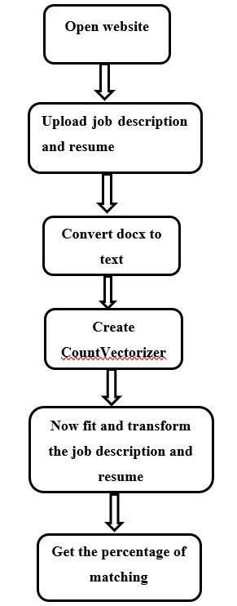

**IMPLEMENTATION**

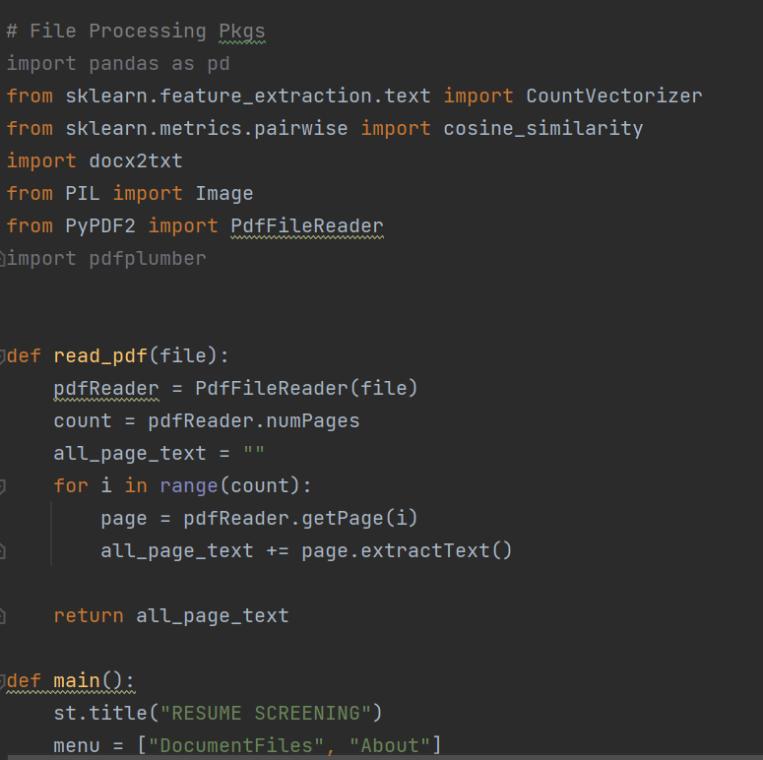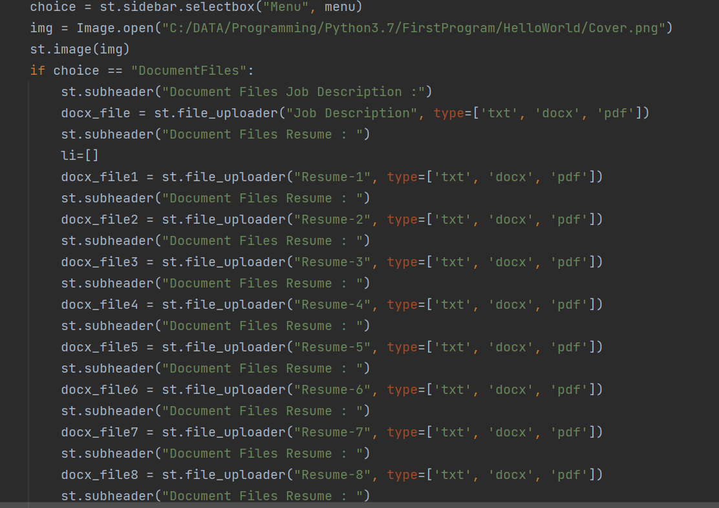

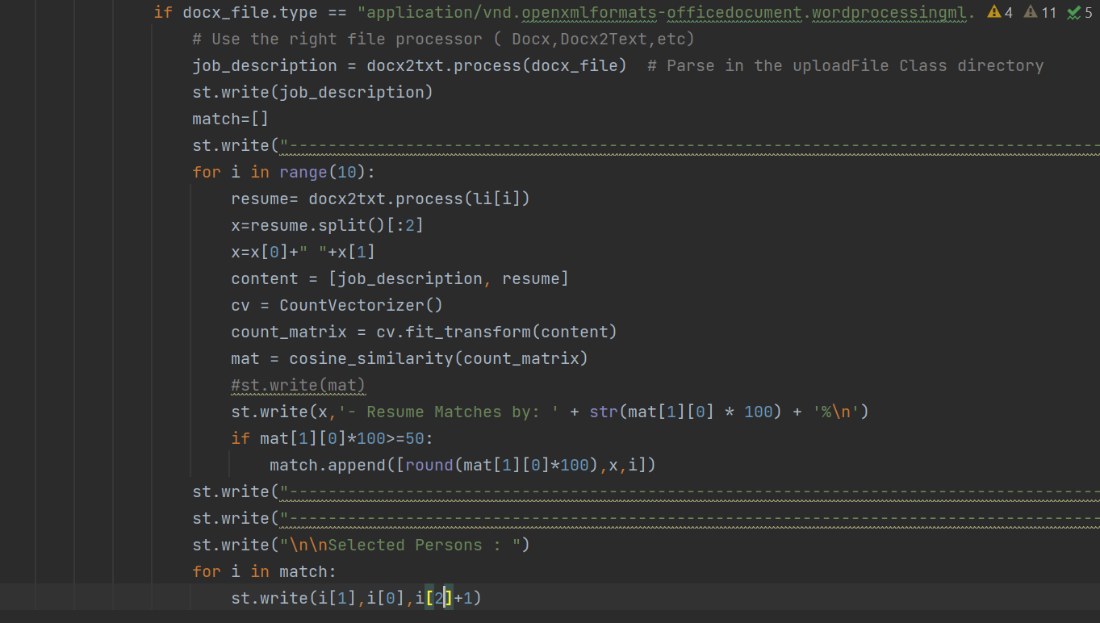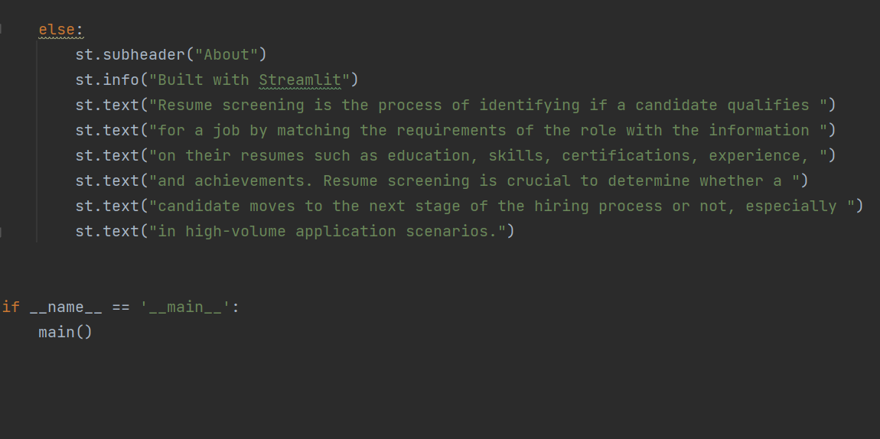

**RESULTS AND ANALYSIS**

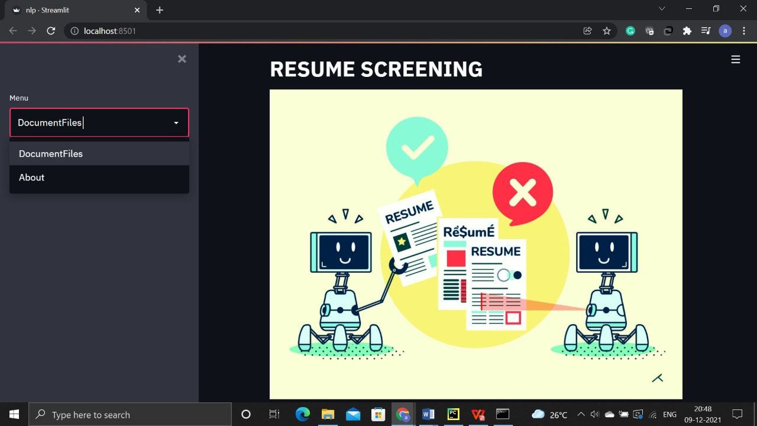 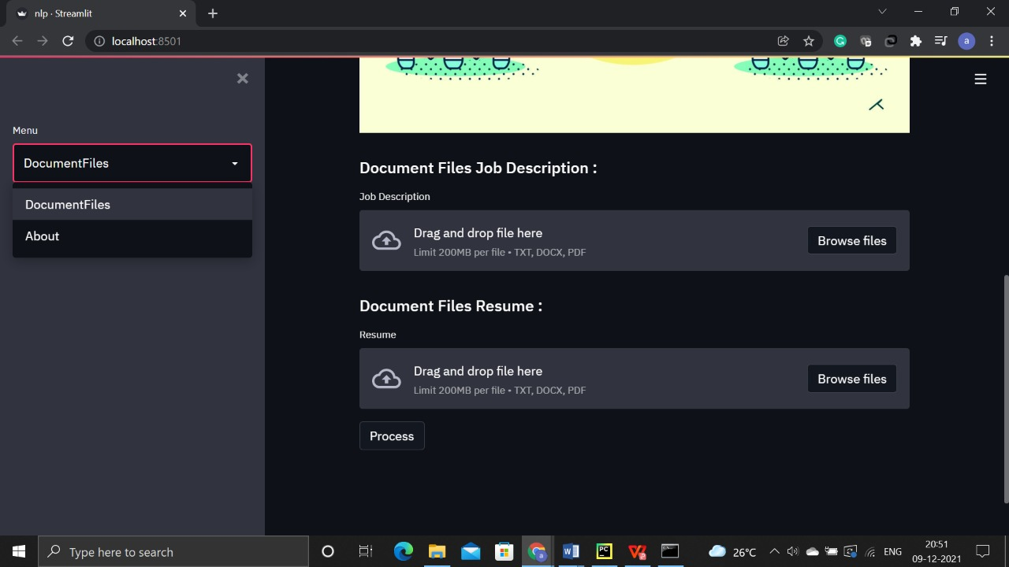

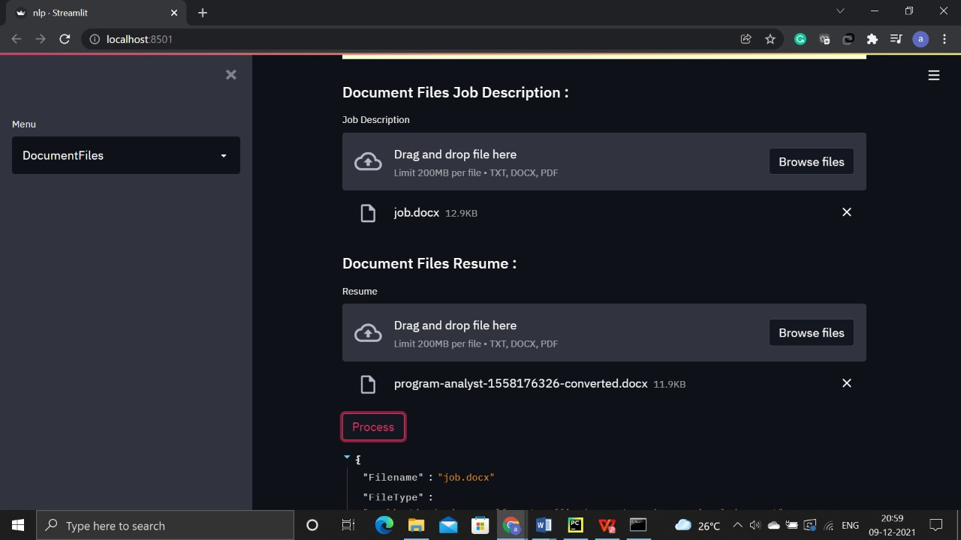

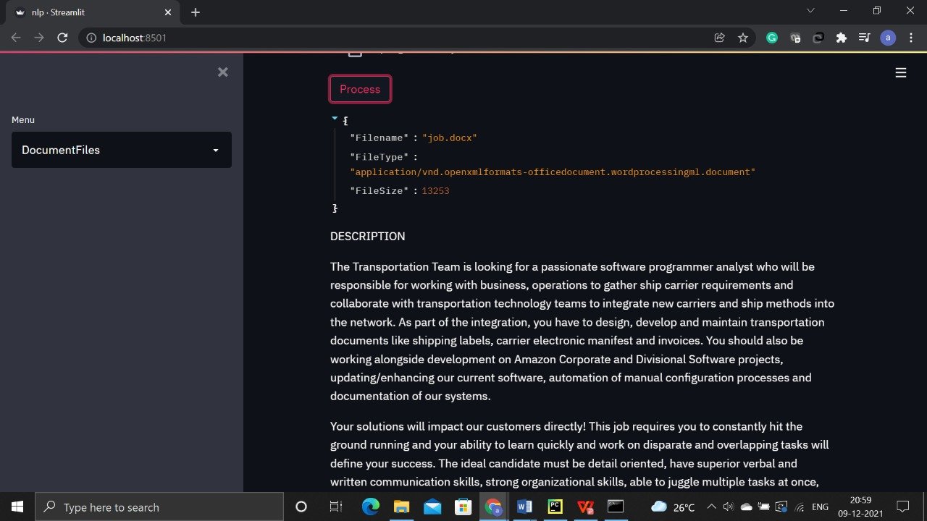

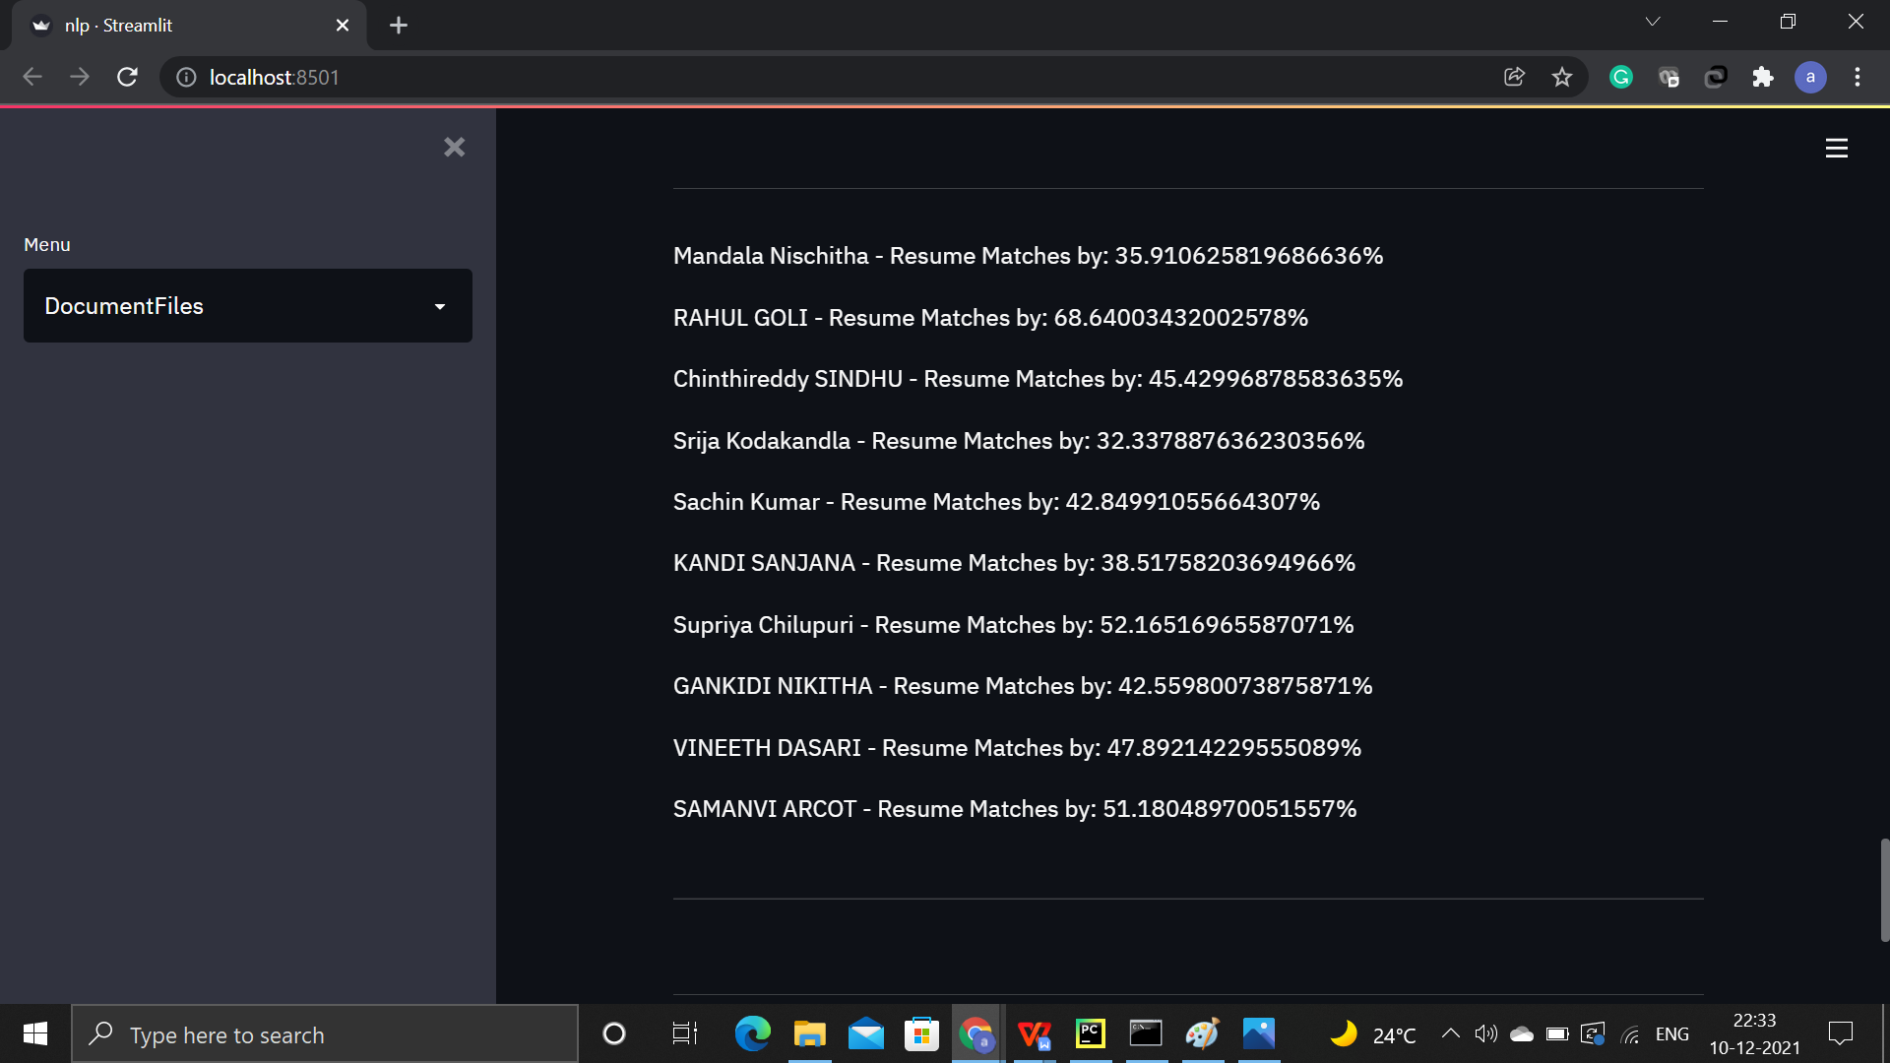

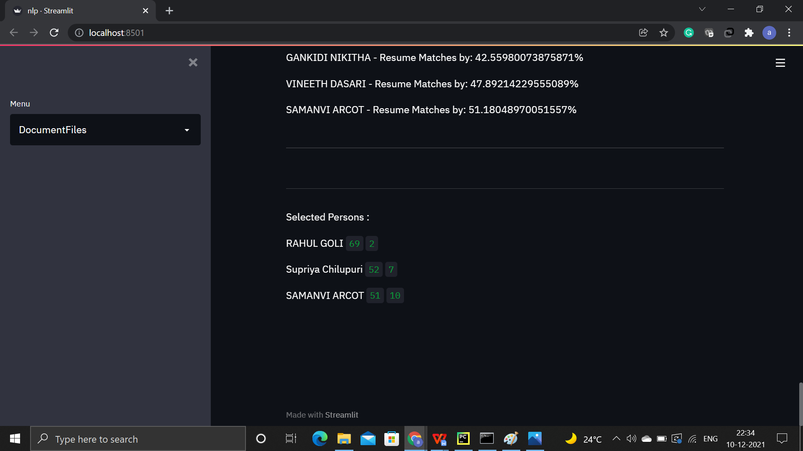

**CONCLUSION**

The process of deciding whether a candidate is qualified for a position based on student education, experience, and other information on their CV is known as resume screening. Frequently, the wrong individuals are chosen, delaying the hiring process. Hr and recruiting team are unable to decide the good candidates from the applications. So, we are trying to develop a website that compares the role/job description with the resumes of different students. We are comparing around 10 resumes with the job profile and printing the matching percentage. After finding the percentage, if the percentage is greater than 50 then, we select the candidates. This application will help Hr and recruiting team. In the future, we want to increase the number of resumes uploaded in the resume.

**REFERENCES**

1. [Sujit Amin](https://www.researchgate.net/profile/Sujit-Amin) et all. “Web Application for Screening Resume”. Published on January 2019. <https://ieeexplore.ieee.org/document/8945869>

[2] [Chirag Daryani](https://www.researchgate.net/scientific-contributions/Chirag-Daryani-2186733137) et all. “AN AUTOMATED RESUME SCREENING SYSTEM USING NATURAL LANGUAGE PROCESSING AND SIMILARITY”. Published on January 2020.https://www.researchgate.net/publication/347633082_AN_AUTOMATED_RESUME_SCREENING_SYSTEM_USING_NATURAL_LANGUAGE_PROCESSING_AND_SIMILARITY

1. Nirali Bhaliya et all. “NLP based Extraction of Relevant Resume using Machine Learning”.<https://www.ijitee.org/wpcontent/uploads/papers/v9i7/F4078049620.pdf>

[4] Daryani, Chirag & Chhabra, Gurneet & Patel, Harsh & Chhabra, Indrajeet & Patel, Ruchi. (2020). AN AUTOMATED RESUME SCREENING SYSTEM USING NATURAL LANGUAGE PROCESSING AND SIMILARITY. 99-103. 10.26480/etit.02.2020.99.103.

[5] <https://www.irjet.net/archives/V7/i7/IRJET-V7I7490.pdf>

[6] <https://chatbotslife.com/ranking-resumes-for-a-given-job-description-using-natural-language-processing-a-toy-project-1f49d3156b44>

[7] <http://www.aiktcdspace.org:8080/jspui/handle/123456789/1553>

[8] <https://ieeexplore.ieee.org/abstract/document/8945869>

[9] Abeer Zaroor, Mohammed Maree and Muath Sabha Conference: 2017 IEEE 29th International Conference on Tools with Artificial Intelligence (ICTAI), Year: 2017, Page 780 DOI: [10.1109/ICTAI.2017.00123](http://dx.doi.org/10.1109/ICTAI.2017.00123)

[10] <https://www.sciencedirect.com/science/article/pii/S2666285X21001011>

[11] <https://repozytorium.amu.edu.pl/handle/10593/25704>

[12] <https://onlinelibrary.wiley.com/doi/abs/10.1002/job.769>

[13] Recruiters’ Inferences of Applicant Personality Based on Resume Screening: Do Paper People have a Personality -Michael S. Cole, Hubert S. Feild, William F. Giles & Stanley G. Harris

[14] The importance of representative design in judgment tasks: The case of résumé screening-Barbara A. Fritzsche,Michael T. Brannick

[15]

https://www.researchgate.net/profile/RolandPepermans/publication/310672378_Ethnic_discrimination_during_resume_screening_Interactive_effects_of_applicants_ethnic_salience_with_job_context/links/609a9fee92851c490fd2ba78/Ethnic-discrimination-during-resume-screening-Interactive-effects-of-applicants-ethnic-salience-with-job-context.pdf